Florida International University

Project #2
Introduction to RB PICO
EML 4804 Introduction to Mechatronics

Submitted By:
Elyion Clyburn
PID 6410764
Date of submission:
09/21/2025

Fall, 2025
Introduction
The purpose of this project is to understand basic coding and implementing them into the Raspberry Pi PICO board and components of the circuit. The basis of all mechatronics is rooted in programming, electronic components, and mechanical components. While the first lab was an introduction to basic circuits, covering the theory required to safely handle electricity without starting an electric fire, this lab was used as a way to familiarize students with coding the components of circuits.

Materials used
- Breadboard
- Raspberry PICO board
- Blue LED
- resistor 220 Ohm
- USB-A to micro-USB wire
- Circuit wires

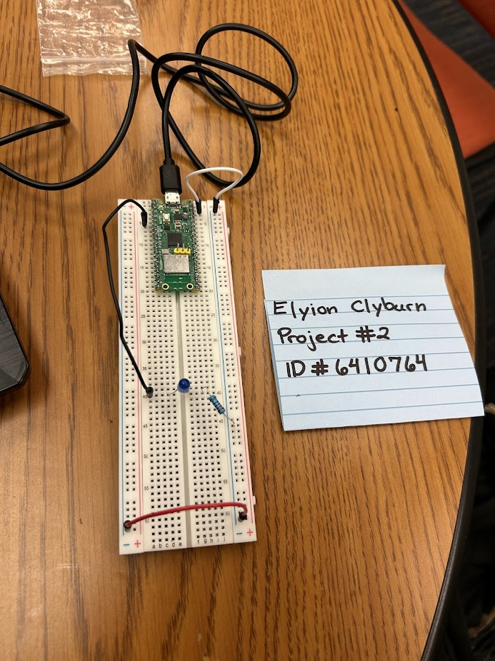
Picture
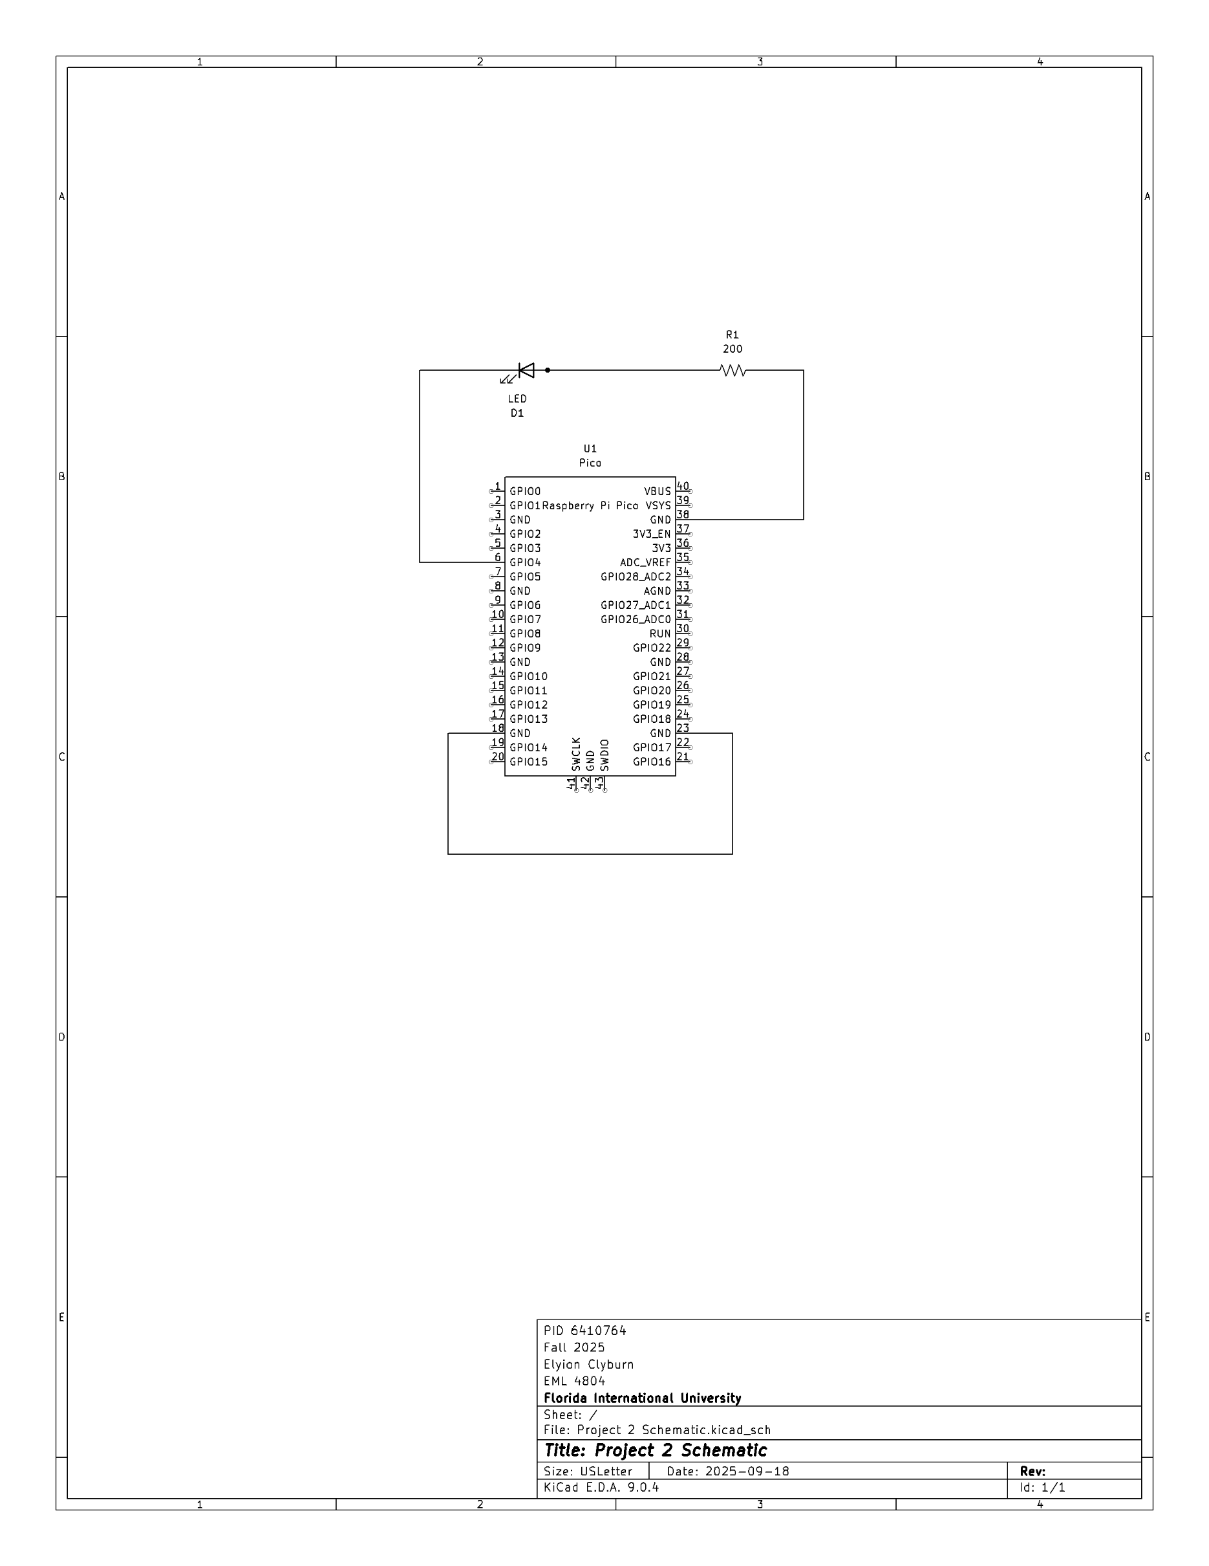
Code
import machine, time
#My PID is 6410764
#Because I have repeating numbers, it makes sense to create multiple functions
#and then run them in the order of my PID
led0 = machine.Pin(4, machine.Pin.OUT)
#Creating all my functions
def six(light):
light.on()
time.sleep(3)
light.off()
time.sleep(1)
light.on()
time.sleep(1)
light.off()
time.sleep(1)
light.on()
time.sleep(1)
light.off()
time.sleep(1)
light.on()
time.sleep(1)
light.off()
time.sleep(1)
light.on()
time.sleep(1)
light.off()

def four(light):
light.on()
time.sleep(1)
light.off()
time.sleep(1)
light.on()
time.sleep(1)
light.off()
time.sleep(1)
light.on()
time.sleep(1)
light.off()
time.sleep(1)
light.on()
time.sleep(1)
light.off()
time.sleep(1)
light.on()
time.sleep(3)
light.off()

def one(light):
light.on()
time.sleep(1)
light.off()
time.sleep(1)
light.on()
time.sleep(3)
light.off()
time.sleep(1)
light.on()
time.sleep(3)
light.off()
time.sleep(1)
light.on()
time.sleep(3)
light.off()
time.sleep(1)
light.on()
time.sleep(3)
light.off()

def zero(light):
light.on()
time.sleep(3)
light.off()
time.sleep(1)
light.on()
time.sleep(3)
light.off()
time.sleep(1)
light.on()
time.sleep(3)
light.off()
time.sleep(1)
light.on()
time.sleep(3)
light.off()
time.sleep(1)
light.on()
time.sleep(3)
light.off()

def seven(light):
light.on()
time.sleep(3)
light.off()
time.sleep(1)
light.on()
time.sleep(3)
light.off()
time.sleep(1)
light.on()
time.sleep(1)
light.off()
time.sleep(1)
light.on()
time.sleep(1)
light.off()
time.sleep(1)
light.on()
time.sleep(1)
light.off()

def wait(light):
light.off()
time.sleep(5)

def end(light):
light.off()

#Blinking my panther ID
six(led0)
wait(led0)
four(led0)
wait(led0)
one(led0)
wait(led0)
zero(led0)
wait(led0)
seven(led0)
wait(led0)
six(led0)
wait(led0)
four(led0)
Video Link
https://youtube.com/shorts/YENpWfqNBI8?feature=share

Conclusion
- What have you learned?
From this assignment, I learned how to use a Python program to code a circuit
- How difficult was this assignment?
This assignment was not difficult at all, just tedious if anything. Creating the circuit was easy because it’s what we did for the first lab, writing the code was just tedious because I had to define five numbers by turning the light on and off and on an off repetitively.
- How did you overcome challenges?
With the tediousness of the assignment being the only “challenge” I experienced, the way I overcame it was by copy-pasting the function of one number to the function of each one and changed the values of the timer.

References
Home Project #2 Introduction to RB PICO Canvas Rubric

